Lambda trigger

Triggering a lambda function by API gateway stores the information

Steps:
- Create A DynamoDB table
- Create lambda function
- Create rest API method with get and put method and create a deployment

Create DynamoDB bucket
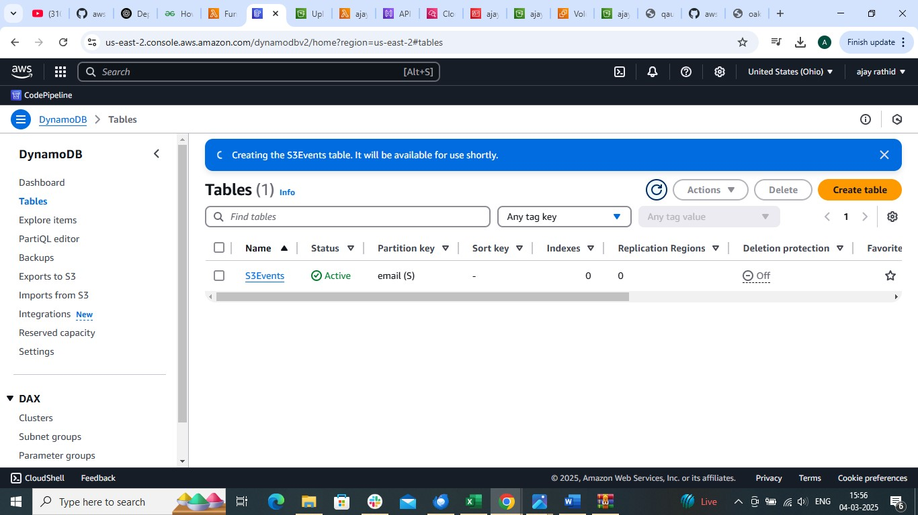

Create lambda function
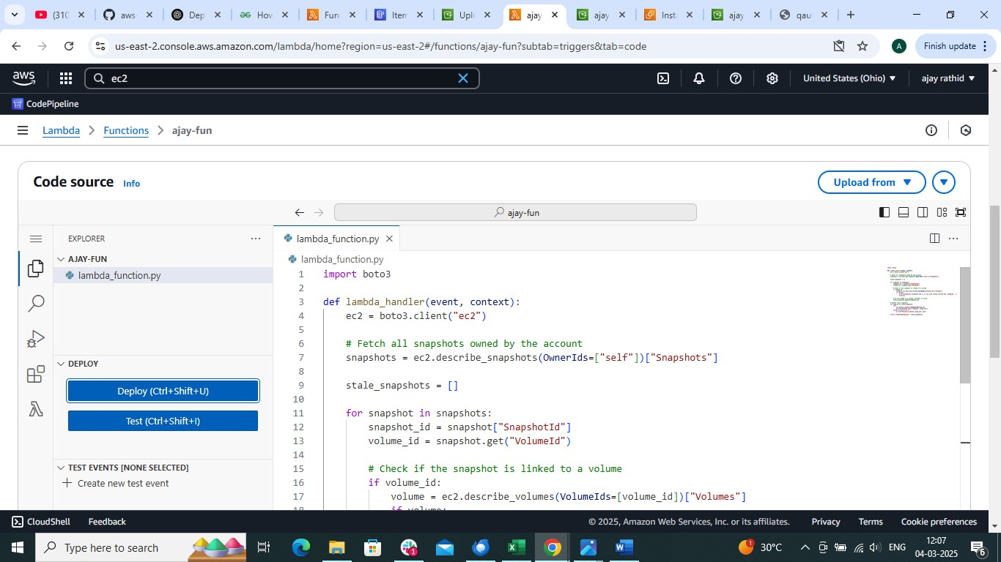
And upload .zip file of source code or use the code which should conatin following code
Contact.py file

<!DOCTYPE html>
<html lang="en">
<head>
<meta charset="UTF-8">
<meta name="viewport" content="width=device-width, initial-scale=1.0">
<title>Contact Form</title>
<style>
body {
font-family: 'Arial', sans-serif;
background-color: #f4f4f4;
margin: 0;
padding: 0;
display: flex;
flex-direction: column;
align-items: center;
height: 100vh;
}

form {
background-color: #fff;
padding: 20px;
border-radius: 8px;
box-shadow: 0 0 10px rgba(0, 0, 0, 0.1);
transition: transform 0.3s ease-in-out;
}

h2 {
text-align: center;
color: #333;
margin-bottom: 20px;
}

label {
display: block;
margin: 10px 0 5px;
color: #555;
}

input,
textarea {
width: 100%;
padding: 10px;
margin-bottom: 10px;
box-sizing: border-box;
border: 1px solid #ccc;
border-radius: 4px;
}

input[type="submit"] {
background-color: #4caf50;
color: #fff;
cursor: pointer;
font-size: 16px; /* Increased text size for submit button */
}

input[type="submit"]:hover {
background-color: #45a049;
}

/* Additional styles for animation */
form:hover {
transform: scale(1.05);
}

/* Additional styles for footer */
footer {
margin-top: 20px;
font-size: 18px;
text-align: center;
}
</style>
</head>
<body>

<h2>Welcome to my AWS Project Task</h2>

<form action="/dev" method="post">
<h2>Contact Us</h2>
<label for="fname">First Name:</label>
<input type="text" id="fname" name="fname" required>

<label for="lname">Last Name:</label>
<input type="text" id="lname" name="lname" required>

<label for="email">Email ID:</label>
<input type="text" id="email" name="email" required>

<label for="message">Message:</label>
<textarea id="message" name="message" rows="4" cols="50" required></textarea>

<input type="submit" value="Submit">
</form>

<footer>
An AWS Project by Avinash Reddy Thipparthi
</footer>

<!-- Simple JavaScript for animation -->
<script>
const form = document.querySelector('form');

form.addEventListener('mouseover', () => {
form.style.transform = 'scale(1.05)';
});

form.addEventListener('mouseout', () => {
form.style.transform = 'scale(1)';
});
</script>

</body>
</html>

Lambda_function.py

import json
import os
import boto3

def lambda_handler(event, context):
try:
mypage = page_router(event['httpMethod'], event['queryStringParameters'], event['body'])
return mypage
except Exception as e:
return {
'statusCode': 500,
'body': json.dumps({'error': str(e)})
}

def page_router(httpmethod, querystring, formbody):
if httpmethod == 'GET':
try:
with open('contactus.html', 'r') as htmlFile:
htmlContent = htmlFile.read()
return {
'statusCode': 200,
'headers': {"Content-Type": "text/html"},
'body': htmlContent
}
except Exception as e:
return {
'statusCode': 500,
'body': json.dumps({'error': str(e)})
}

elif httpmethod == 'POST':
try:
insert_record(formbody)
with open('success.html', 'r') as htmlFile:
htmlContent = htmlFile.read()
return {
'statusCode': 200,
'headers': {"Content-Type": "text/html"},
'body': htmlContent
}
except Exception as e:
return {
'statusCode': 500,
'body': json.dumps({'error': str(e)})
}

def insert_record(formbody):
formbody = formbody.replace("=", "' : '")
formbody = formbody.replace("&", "', '")
formbody = "INSERT INTO avinashtable value {'" + formbody + "'}"

client = boto3.client('dynamodb')
response = client.execute_statement(Statement=formbody)
# Assuming the execute_statement call returns successfully
return response

success.py
<!DOCTYPE html>
<html lang="en">
<head>
<meta charset="UTF-8">
<meta name="viewport" content="width=device-width, initial-scale=1.0">
<title>Thank You</title>
<style>
body {
font-family: 'Arial', sans-serif;
background-color: #f4f4f4;
margin: 0;
padding: 0;
display: flex;
justify-content: center;
align-items: center;
height: 100vh;
}

h2 {
text-align: center;
color: #333;
padding: 20px;
background-color: #fff;
border-radius: 8px;
box-shadow: 0 0 10px rgba(0, 0, 0, 0.1);
opacity: 0;
transform: translateY(20px);
transition: opacity 0.5s ease-in-out, transform 0.5s ease-in-out;
}

/* Additional styles for animation */
.visible {
opacity: 1;
transform: translateY(0);
}
</style>
</head>
<body>

<h2 id="thankYouMessage">Thanks for trying this Project. you can verify data in DynamoDB Table.</h2>

<!-- Simple JavaScript for animation -->
<script>
const thankYouMessage = document.getElementById('thankYouMessage');

// Adding a delay before showing the message
setTimeout(() => {
thankYouMessage.classList.add('visible');
}, 500);
</script>

</body>
</html>

deploy

Create REST api method
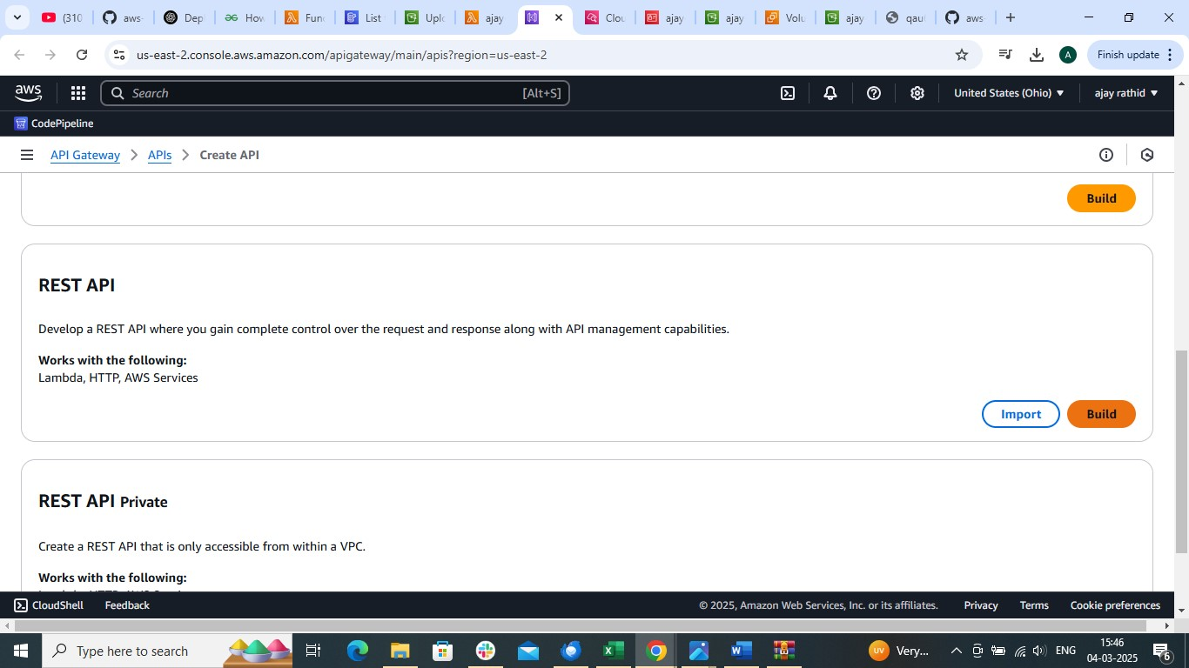

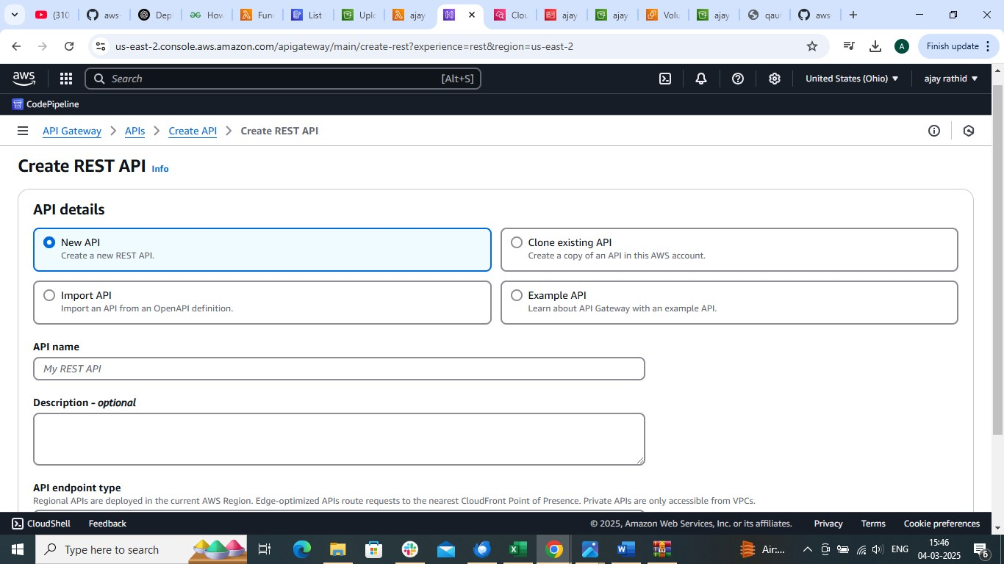

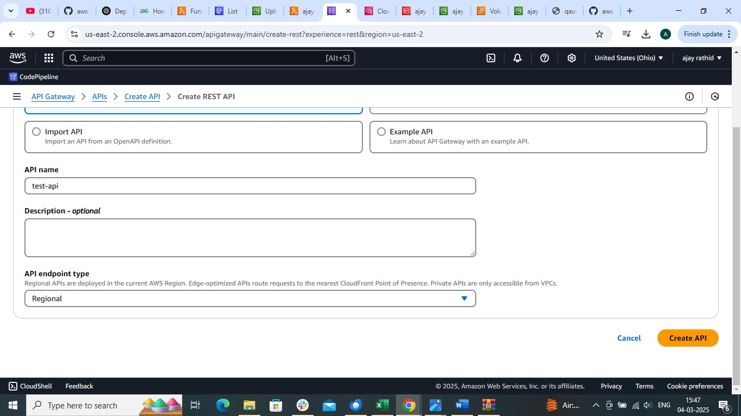

create method get
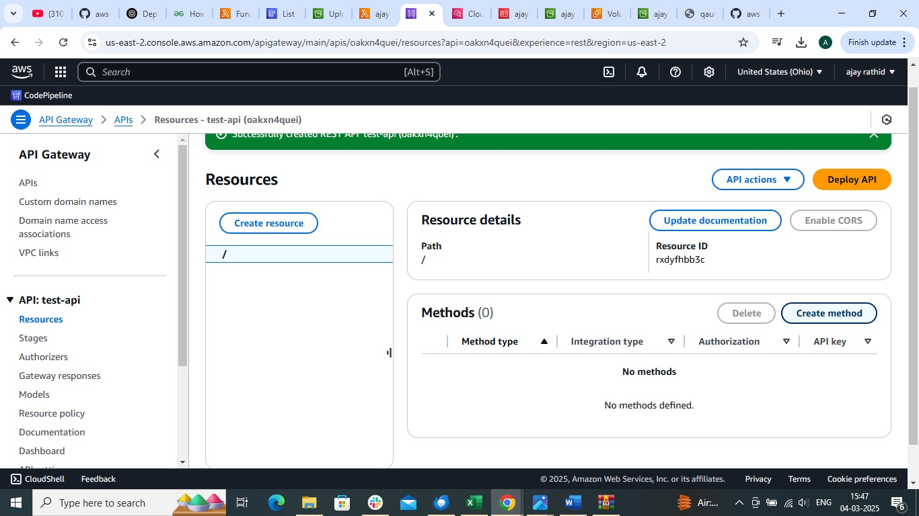

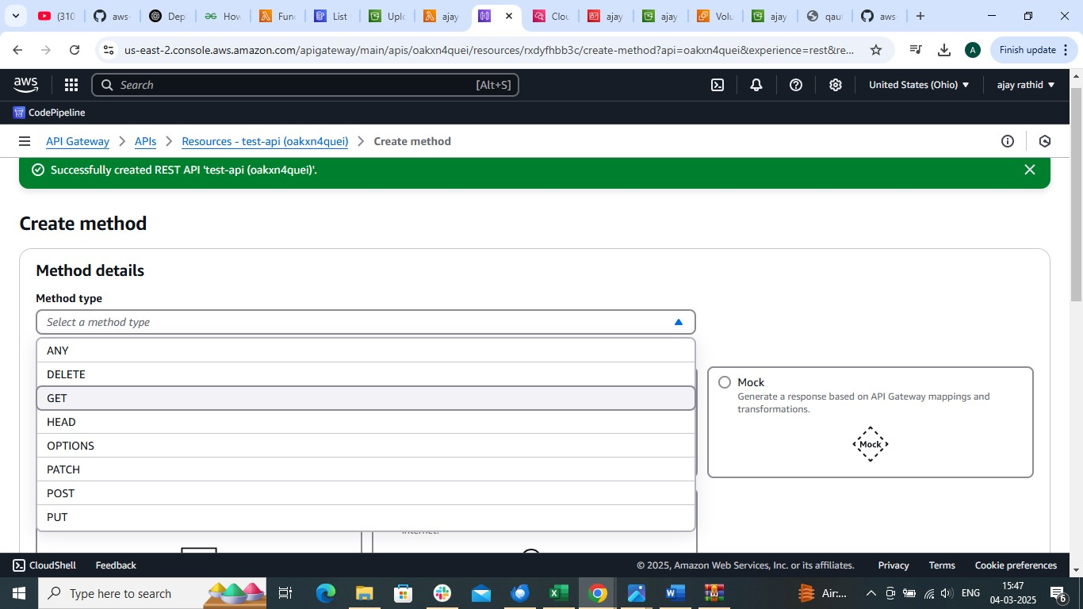

lambda
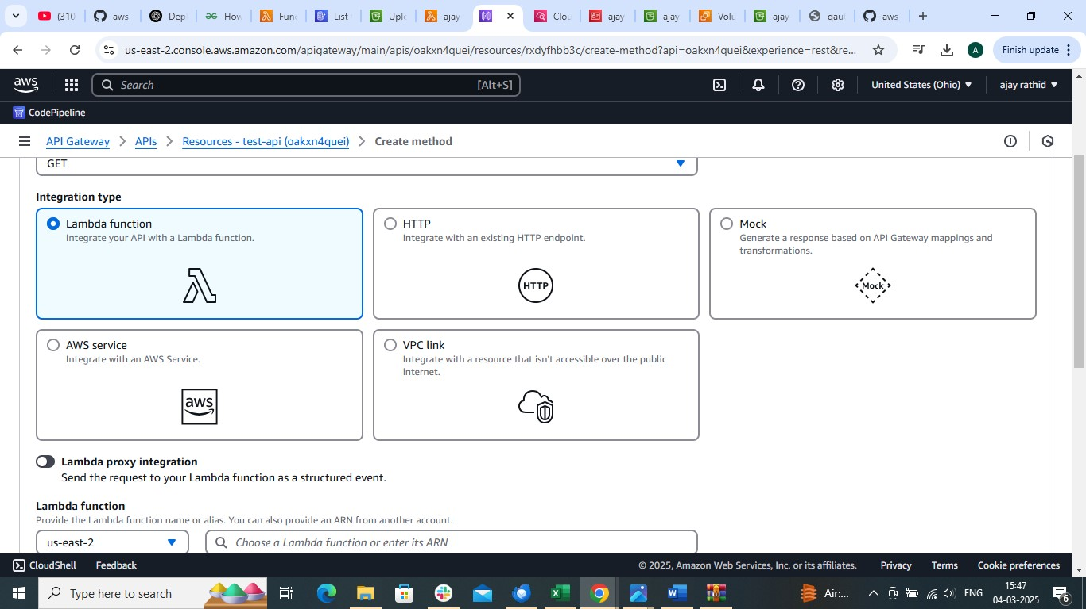

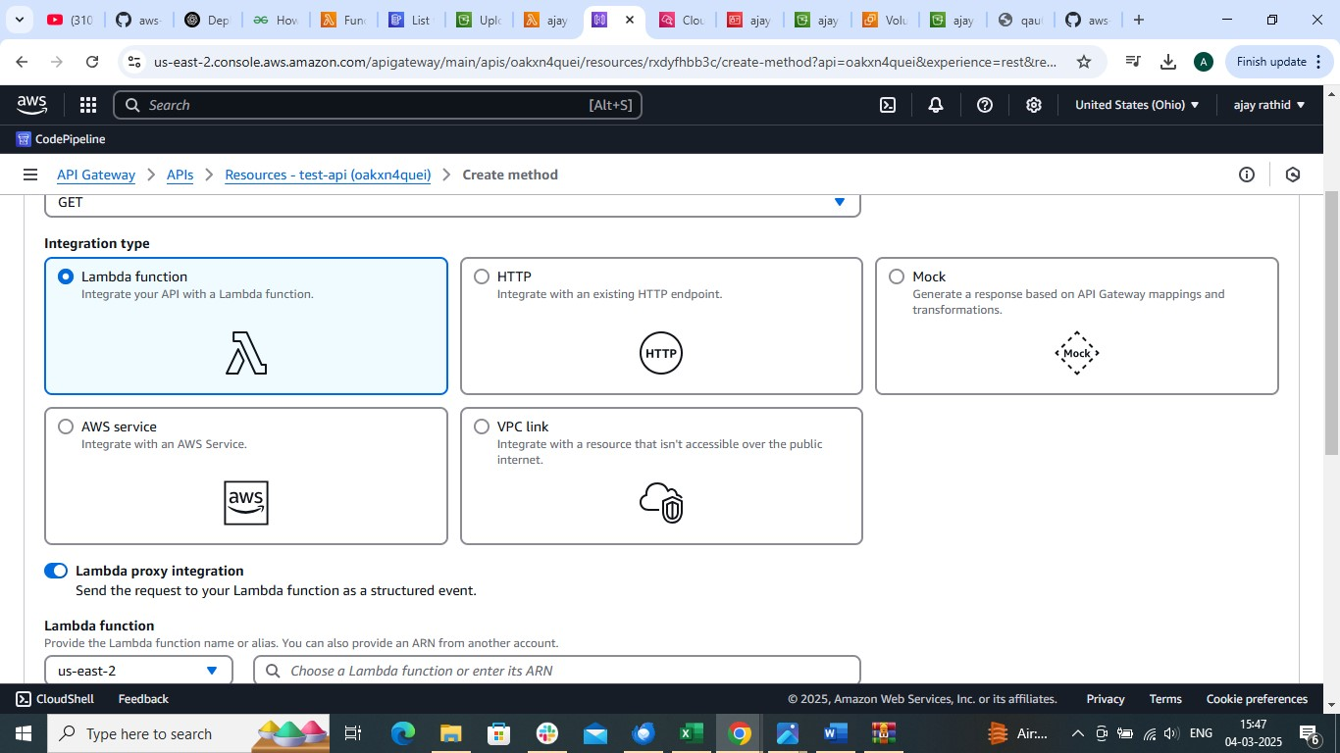

Choose lambda function
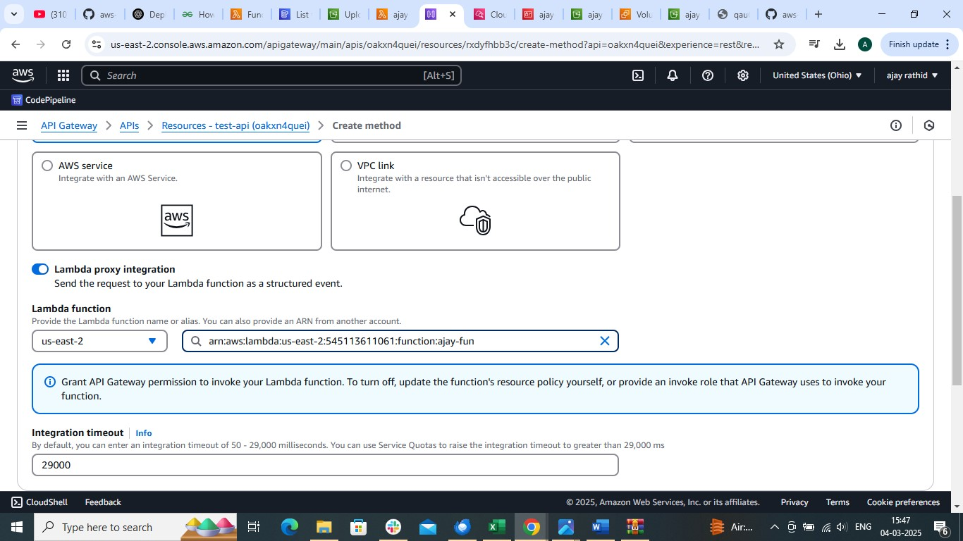

create
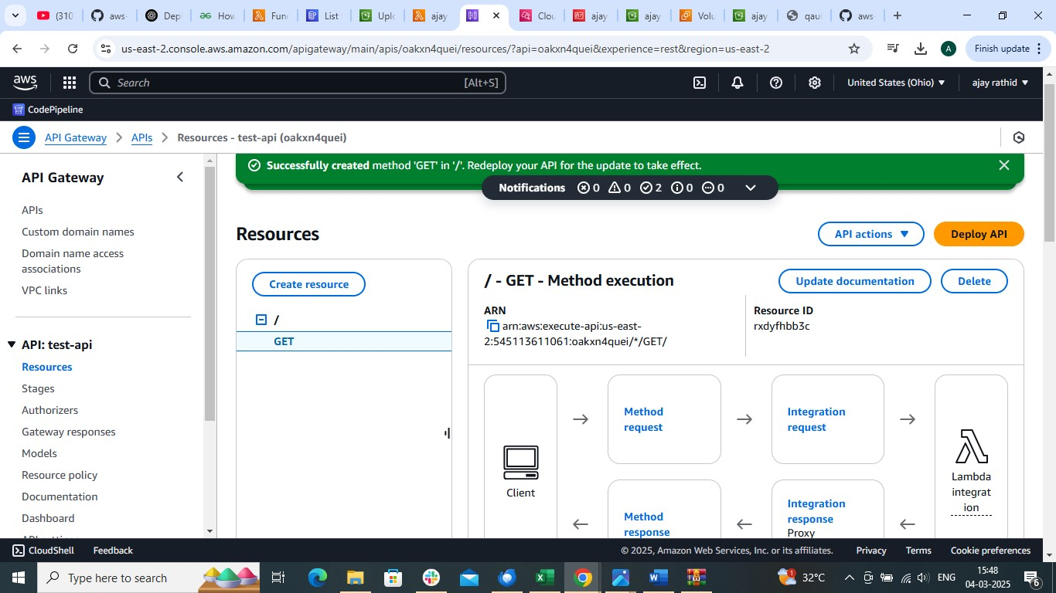

Same way POST method
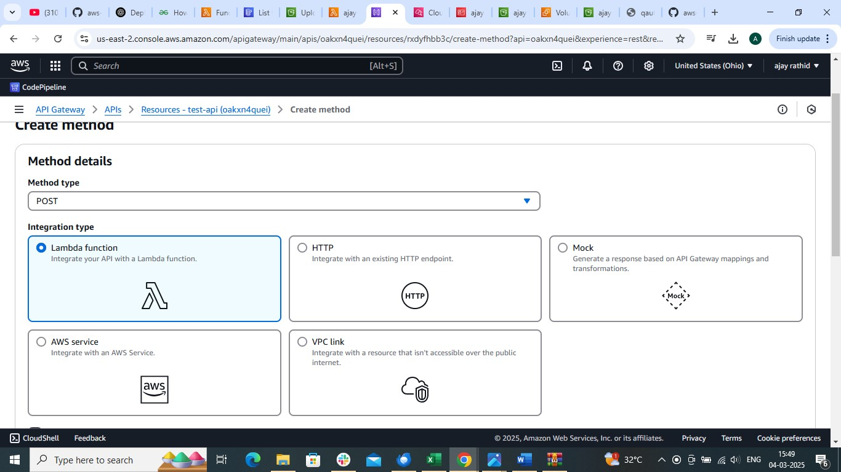

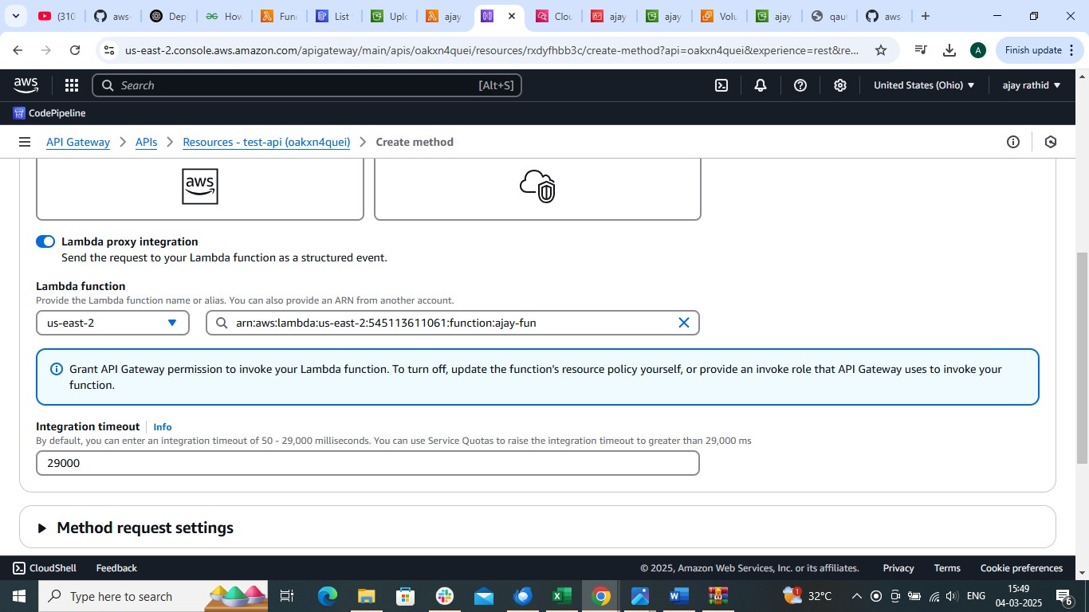

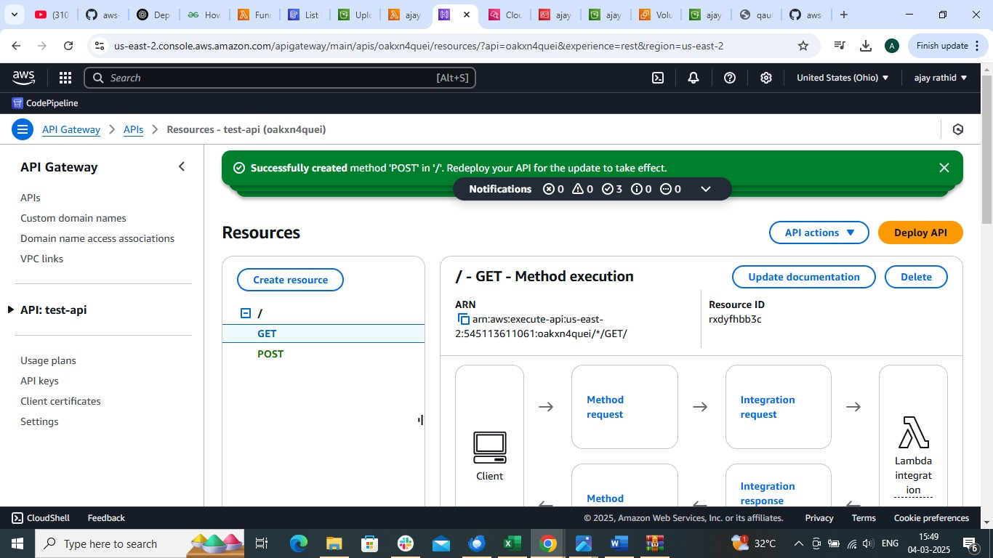

deploy api
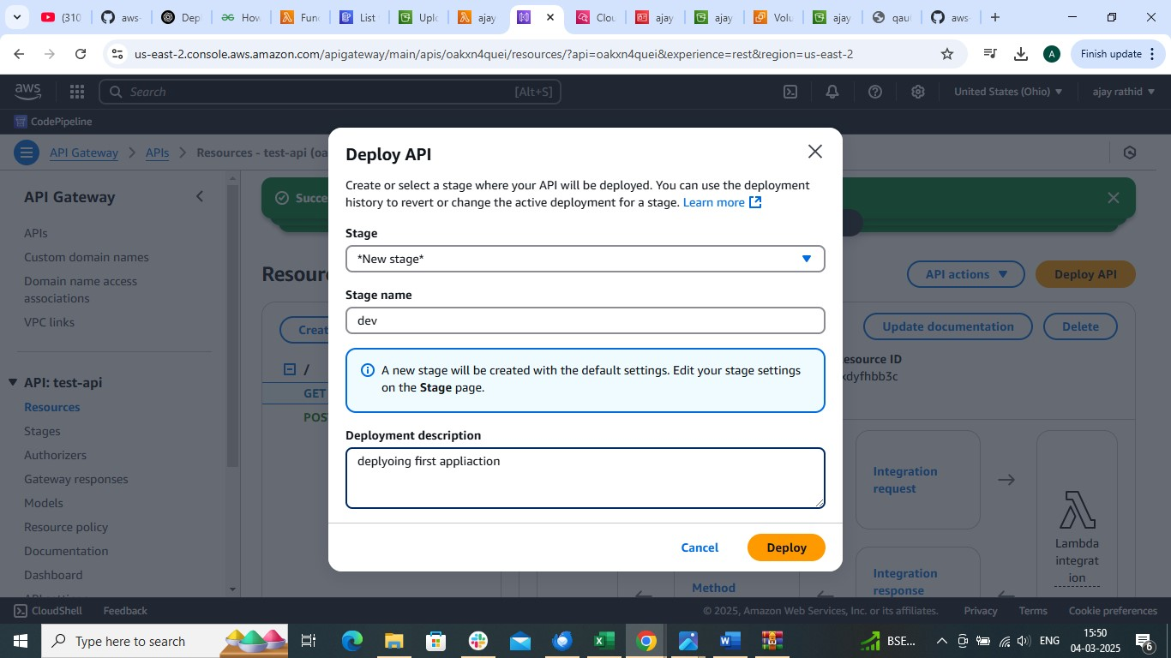

Create deploy
Copy url and paste in browser
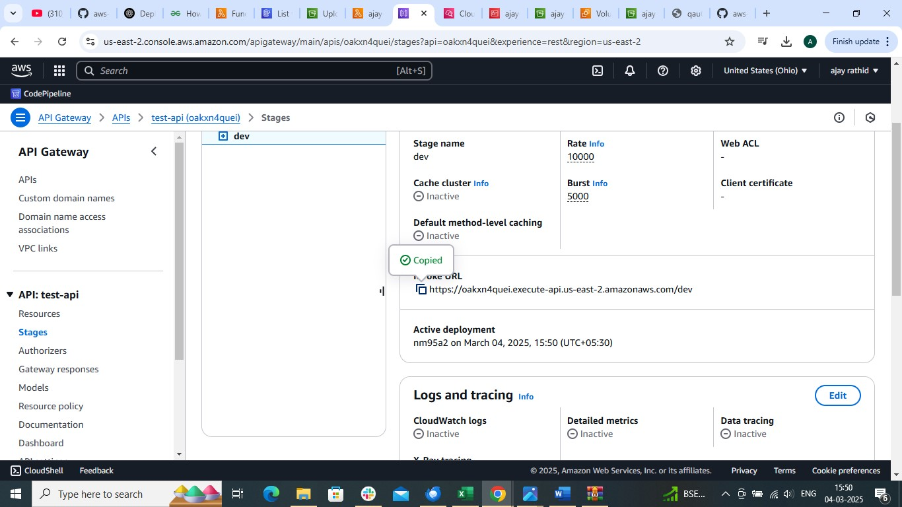

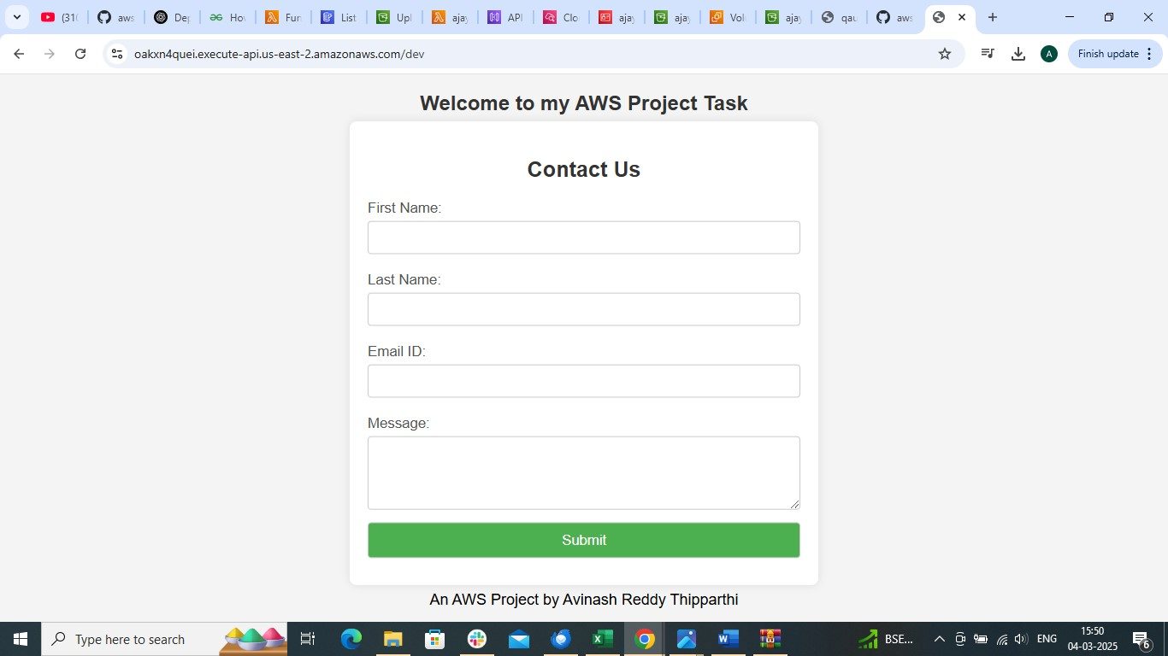

Now add the datails and submit
As soon you click on submit it will trigger lambda function store the information in DynamoDb table
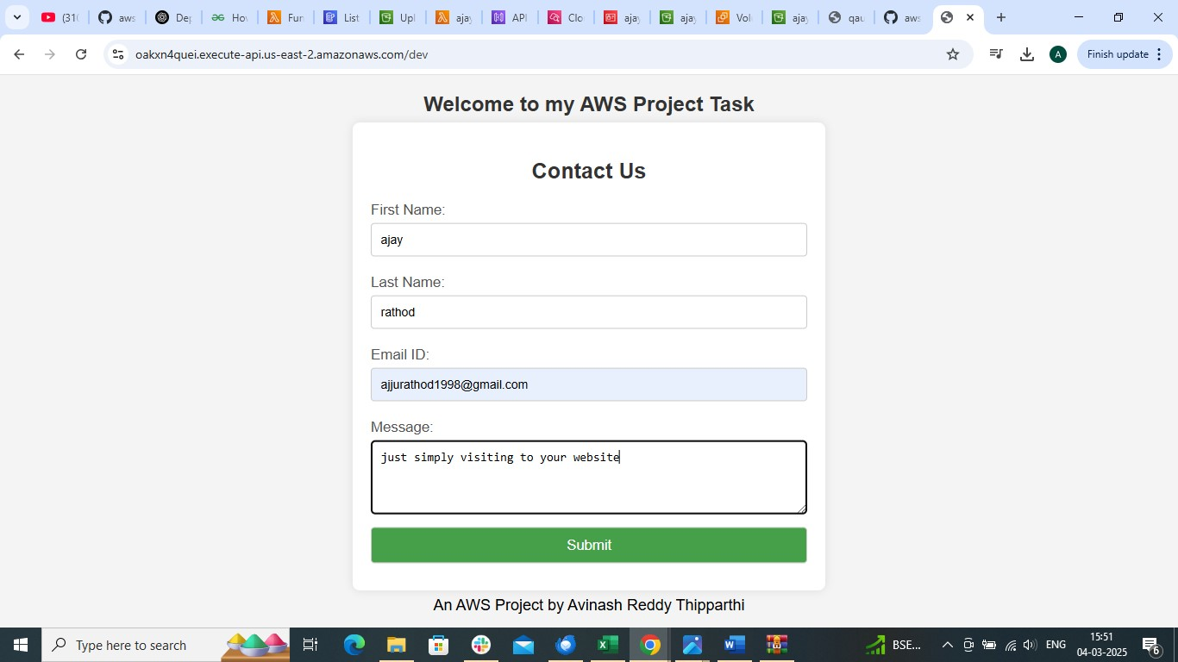

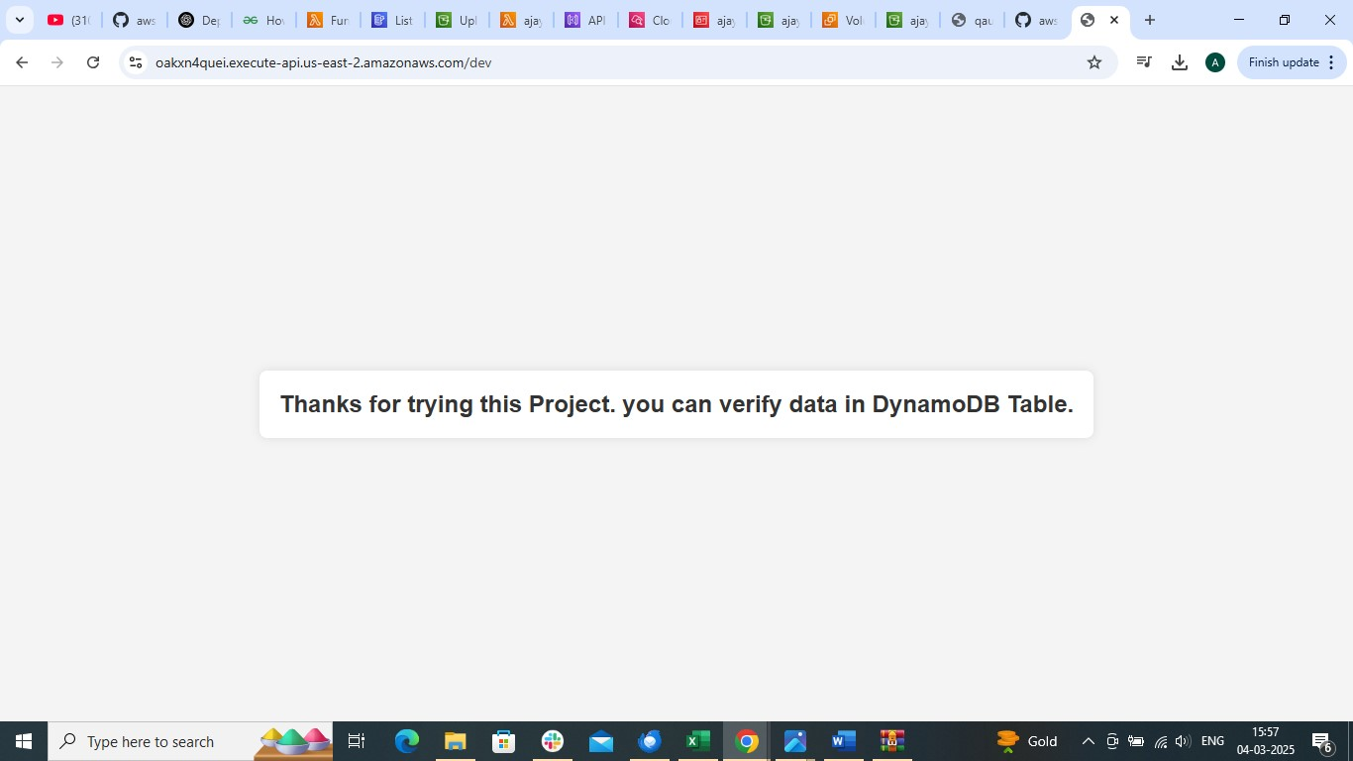

Open the table see open Item
